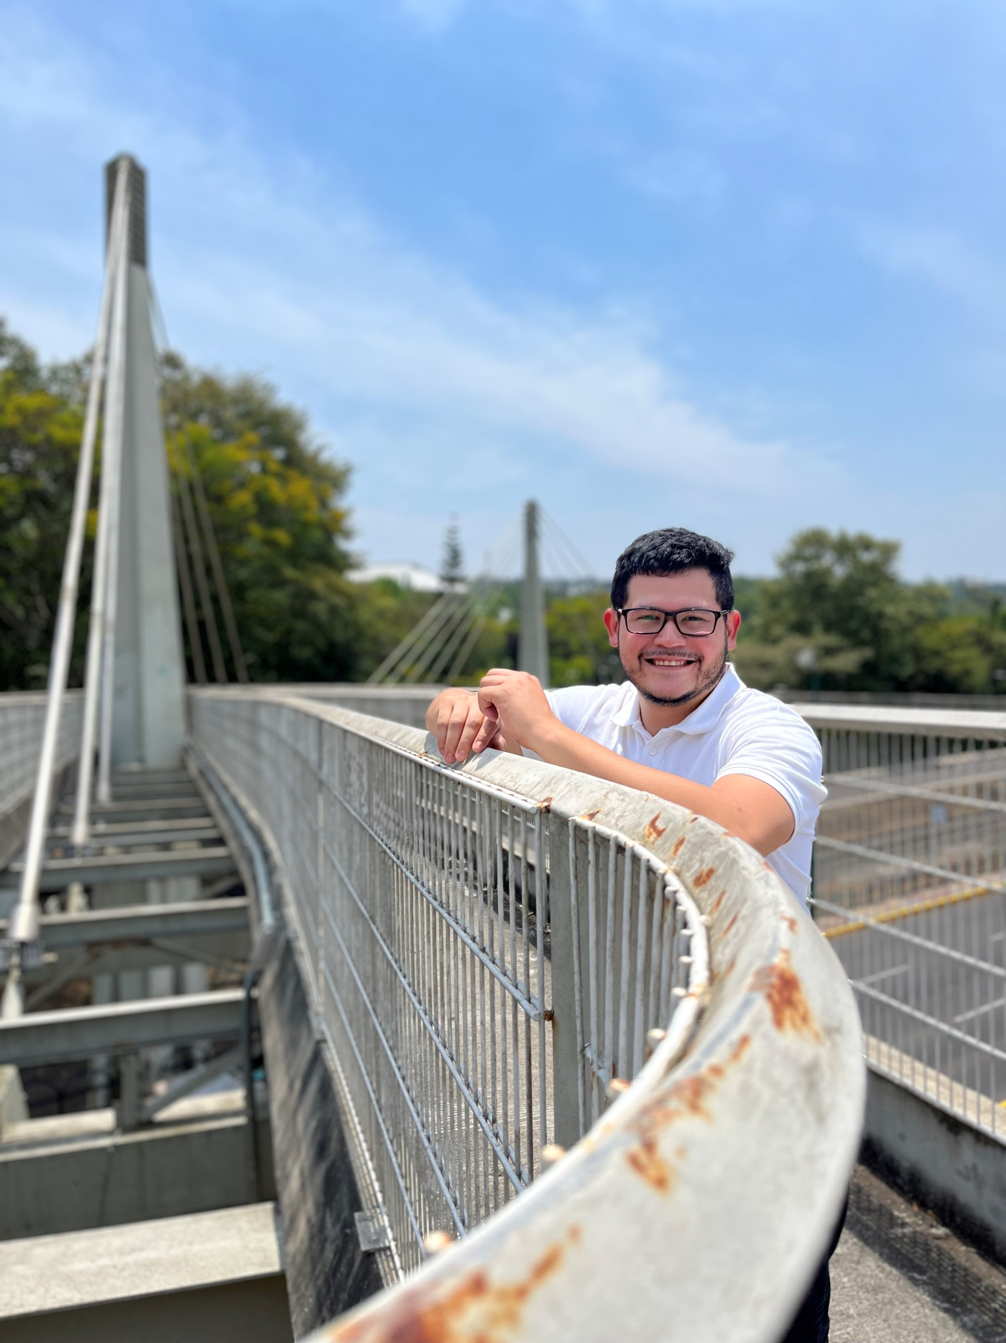  "The software development process is like a never-ending game of chess."  - Unknown  CONTACT  edwin.estro@me.com  +522283081889  Personal website:  edwinestro.github.io  Example project website:  comuniwasd.github.io  Family business’ website:  (I’m in charge)  www.xalapawok.com  Hobbies  - PC building  - Powerlifting  - Writing  - Web development  languages  - English: Proficient  - French: Proficient  - Spanish: Native  certifications  - Codecademy: Learn Java  - EF: SET English C2 Proficient |  | Edwin I. Estrada R.  Software Developer  Introduction  My first “Hello, World!” was made in 2010 using C++ Language. I didn’t take a lot of interest in programming until later years.  Switched to an informatics career in 2019, have been studying programming in different universities in México and Spain. Experience in making websites and knowledge in how computers think. Therefore, I understand how high-level programming languages are translated to machine language, which I believe is important to make fast, light websites/apps.  Knowledge in ALM to maintain order while deploying software.  I have enough experience managing employees to understand what the main problems are when working with humans.  Work Experience  Manager  At “WASD Gaming Center” a Computer Gaming Cybercafé.  From July 2015 to March 2022.  - Managed Projects involving project definition, a milestone plan, and a risk list.  - Led the staff to achieve goals and improve work tasks while maintaining companions happy in their work environment and clients satisfied while consuming in our establishment.  - Dealt with a lot of changes as we understood our client’s necessities.  - Implementing Excel as our organization’s control software so we could facilitate work and avoid papers.  Education  Software Engineering (Currently studying)  Universidad Veracruzana  Expected Graduation: June 2024  Relevant coursework: Fundamentals of Programming, Computability and Complexity Theory, Design and Analysis of Algorithms, Computer Language Engineering, Object-Oriented Programming with Java, Practical Java Applications  Computer Engineering (Incomplete, had to come back to México due to the Pandemic).  Universidad de Málaga  Málaga, Spain  August 2019–December 2020  Relevant coursework: Computer Physics, Discrete Mathematics, Computational Statistics, Enterprise Organization, Fundamentals of Programming, Object-Oriented Programming with Java.  Expected Graduation: Undefined  Civil Engineering (Incomplete, 33% of credits).  Universidad Nacional Autónoma de México.  Mexico City, México.  August 2010–May 2015  Relevant coursework: Probability and Statistics, Basic computing, Lineal Algebra, Differential, Integral and Vectorial Calculus, Differential equations.  Expected Graduation: Undefined  “Open a door to the future” Volunteering, Universidad de Málaga  Málaga, Spain  August 2020–December 2020  - Recycling old laptops making them usable again by installing Linux distributions, donating them to extremely poor kids to help them breach the digital barrier.  - Wi-Fi Antennas installation in low-income neighborhoods to help the local community start engaging with the digital ambit.  Key Skills  - Teamwork  - Critical Thinking  - Excellent Communication Skills.  - Plenty digital marketing experience.  Programming Languages  - Python, C, C++, Java OOP, R, ARM ASM  - HTML, CSS, JavaScript.

